Verity Instruments Interferometric Endpoint (IEP)
Considerations and Algorithm Capabilities

1. Approaches to IEP Measurement/Algorithms 1
2. Algorithm Comparison Table 4
3. Implementation: 5
4. The Wafer 6
5. Data Needed for Successful IEP Measurement - the following data is normally required: 7

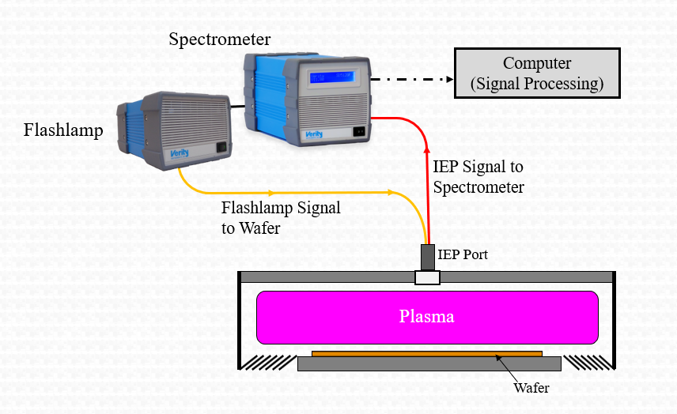

Approaches to IEP Measurement/Algorithms
There are four general approaches to use in IEP:
  - General Reflection Algorithm
  - Thickness Deconvolution Algorithm
  - Fringe Counting
  - Qualitative

General Reflection (GR)
This algorithm functions by comparing a real-time reflection measurement to a computed theoretical model. The GR is normally the most accurate algorithm. It also requires the most effort on the part of the user to produce reliable results. It computes one or more film thicknesses (or depth) for each of the defined stacks from a single spectrum. The following considerations apply:
  - The structure on the wafer cannot be too complicated.
    - Stacks comprised of blanket films are supported
    - Multi-layered film stacks are supported.
    - Multiple zone¹ structures such as line-and space, holes, etc., are supported.
    - Experience with models of more than two zones is limited.
    - Line widths or hole diameters should be at least 500 nm. Below about 500 nm diffraction and polarization effects become important, and the modeling is beyond the scope of the General Reflection Equation.
  - The structure must be well characterized.
    - The model must include reasonably accurate n & k values for each material in the model.
    - The approximate area of the different zones (in % terms) must be known, and constant within a small range.
    - The nominal, minimum, and maximum thickness values should be entered.

Thickness Deconvolution
The Thickness Deconvolution algorithm functions by performing a Fourier transform of the spectral data and then identifying one or more film thicknesses from the power spectrum of the transformed data. The Thickness Deconvolution’s Fourier processing takes data sampled in reciprocal wavelength (the reflectance of the structure), from which the thicknesses can be inferred.

- This algorithm is applicable for structures with vertical dimensions greater than ~ 500 nm. The results are usually less accurate than those of the GR.
- Stacks comprised of blanket films are supported.
- Multiple zones and multi layered are supported
- It requires very little supporting information on the part of the user.
- Generally it is necessary to make a calibration or correlation measurement to relate the output of the algorithm to the true value of the thickness or depth measurement.
- Line widths or hole diameters should be at least 500 nm. Below about 500 nm diffraction and polarization effects become important, and may not be accommodated.

Fringe Counting
The fringe counting algorithms produce measurements of the change in a thickness or depth between two points in time. As such, the fringe counter can only be used for in-situ applications. The depth or thickness change equals: the number of fringes multiplied by the wavelength multiplied by n / 2.
- The usual approach is to pick a specific wavelength to monitor. A rough guideline is that the minimum change in depth or thickness that can be monitored in this way is on the order of the wavelength used (i.e., no less than 400 nm if the wavelength 400 nm is used).
- If two things are changing (e.g. a mask etching while a trench is etching), the number calculated will likely indicate the change in the distance from the top of the mask to the bottom of the trench.
- Line widths or hole diameters should be at least 500 nm. Below about 500 nm diffraction and polarization effects become important, and may not be accommodated.

Qualitative
Even when none of the above specific algorithms can produce quantitative results, IEP can be valuable because of a feature in the reflection data that indicates the endpoint. An example is the onset of interference at a particular wavelength when a film becomes thin enough to be transparent at that wavelength. By collecting the data and examining it in conjunction with metrology may lead to the discovery of such a feature. Spectraview is flexible enough that an algorithm to detect the feature can usually be created using the existing equation set.
¹ Zones refer to spatial regions within a wafer and/or within a die where different film stacks occur. Imagine a line passing through the wafer perpendicular to the surface. The GR model requires specifying the materials and their thicknesses that exist along that line as it passes from a point on the substrate up through the structure. Points that can be specified by the same sequence of materials and thicknesses define a zone. For example, a line and space pattern would consist of two zones.

Algorithm Comparison Table
Depth or Thickness Measurement (using UV/VIS instrument, unless noted otherwise)

Algorithm | Algorithm  Description | Use  In-Situ | Use  In-Line | Most Shallow  (or thinnest) Measurement | Deepest  (or thickest)  Measurement | Most Narrow Linewidth or Hole Diameter | Is Dark Reference Needed? | Is Si Reference Needed? | Is n needed? | Is k needed? |  | When to use algorithm?
General Reflectance | Compare to Model | Yes | Yes | ~ 250 nm * n⁽³⁾  900-1700 nm:  ~ 2 μ | ~ 20μ * n⁽ ¹⁾  900-1700 nm: ~ 65 μ * n | ~ 500nm⁽²⁾ | Yes |  |  |  |  | For thin films,  for best accuracy
Deconvolution | FFT of Spectrum |  |  | ~ 1 micron, (depends on the application) | ~ 20μ * n |  | No, but is helpful | No, but is helpful for improved S/N | Yes |  | Only needed for absolute accuracy⁽⁴⁾ | For thick films,  when no reference data is available
Fringe Counter | Count Fringes |  | No | Wavelength/2*n  (approximately 1 fringe) |  |  | No |  | Only needed for absolute accuracy⁽⁴⁾ |  | No | When change in thickness/depth is needed
Qualitative | Various |  | Yes | ~ a few nm * n  (requires optimized hardware and implementation) | Probably in the range from 20 to 60 μ | ~ 500 nm | Probably not, it depends on the algorithm developed |  | Probably only needed for absolute accuracy |  | Probably only for absolute accuracy | When there is no alternative or if reproducible results are found
¹ - In some applications we have measured to 60 μ depth.
²- In some applications we may be able to measure narrower holes or linewidth using effective medium model as part of the General Reflectance algorithm.
³- Thicknesses below this limit can be measured on blanket films and simple structures, if extra care is taken to control the optical path and absolute intensity.
With the use of the SPD2009, oxide film thickness can be measured with +/-2 nm accuracy down to zero thickness.

⁴- The fringe counter measures a relative change in thickness/depth and the absolute starting and ending thicknesses/depths are not calculated. If “n” is not
used/known, the fringe counter output is scaled to vacuum/air (n=1). When “n” is included the actual change in thickness/depth is determined.

Implementation:
Normal Viewing – Is normal incidence viewing of the wafer possible? Click or tap here to enter text.
  - Normal incidence (perpendicular to wafer surface) is preferred and simplifies the modeling and interpretation of IEP data.
  - Verity’s IEP algorithms assume normal incidence. Quantitative results will be incorrect if other than normal incidence is used.

Window Material – What is the window material? Click or tap here to enter text.
- Verity’s IEP systems typically utilize the wavelength range from 200-800 nm and the window should transmit over this range. For most common applications fused silica or sapphire is recommended
- The performance will be better if most of the light reflected back into the collimator is reflected from the wafer. Therefore, try to minimize the reflection from other surfaces (windows, showerheads, etc).
- Tilted windows are beneficial.
- The window should be polished on both surfaces.

What is the Optical Path Diameter? Click or tap here to enter text.
- 10 mm or greater is desirable. It may be possible to use a smaller diameter, if the development of special optics is justified.

What is the Working Distance? Click or tap here to enter text.
- Distances to about 30 cm are normally acceptable. At longer distances the signal to noise may be reduced and the system becomes more sensitive to alignment, suggesting the use of a tilt stage.

Wafer Clamping- Is the wafer clamped during processing?
- If “no” then wafer tilt may cause a reduction of signal and add measurement error.

The Wafer
Is the area within the measurement spot representative of the wafer?
  - If the observed area does not contain representative pattern density, feature sizes or film thicknesses, this must be taken into account during system qualification.
  - Different feature types within the measurement spot- if there are different feature types within the measurement spot, detailed information (B, C, and D from below) is needed for each feature type.

Feature Sizes – what feature sizes are present?
  - Length: Click or tap here to enter text. Width: Click or tap here to enter text.
    - Wider than 200 microns may be difficult due to lateral coherence limitations.
    - Narrower than ~500 nm may be difficult to measure as the line width is narrower than the wavelength of light.
  - Depth: Click or tap here to enter text.
    - See the table above for depth limitations and algorithm options
  - Drawing: please provide a drawing or sketch of the wafer before and after etch or deposition Click or tap here to enter text.

Materials- what materials are present?
  - Etched material: Click or tap here to enter text.
  - Mask: Click or tap here to enter text.
  - What is the selectivity: Click or tap here to enter text.

Open Area –what % of the feature being measured is etched? Click or tap here to enter text.

Data Needed for Successful IEP Measurement - the following data is normally required:
Full run with large open area or blanket data - for example a silicon dioxide blanket wafer. This data is used to determine the stability of the system.

Dark Data - using backside of wafer or chuck for the dark reference. This data is used to determine the impact of window reflections and ambient light.

Si reference data – the bare Si wafer should be clamped in the same manner as the wafer will be. This data is used to determine absolute or relative reflectivity of any processed wafer.

