**Applications Assistance Worksheet**

Verity Instruments is ready to help customers use Verity sensors to develop Optical Emission Spectroscopy (OES) endpoint solutions for their processes. As an OES supplier, Verity’s experience can be more quickly applied to solving customer problems when the background information requested in this Applications Assistance Worksheet is supplied.

**Please complete this form to the best of your ability and email it to your Verity Instruments contact or** [**customerservice@verityinst.com**](mailto:customerservice@verityinst.com)**.**

Name: Click or tap here to enter text.

Company: Click or tap here to enter text.

Address: Click or tap here to enter text.

City, State, Zip: Click or tap here to enter text.

Telephone: Click or tap here to enter text.

Email: Click or tap here to enter text.

1. Traditional OES Endpoint detects a spectral change in the plasma emission in close proximity to the film being etched. The film can be on the wafer being etched or on the walls of the reaction chamber in a cleaning operation. Is light emitted from the region close to the film being etched?  **Yes**  **No**
2. OES Endpoint can be detected from any or all three possible changes in the plasma light emission:
   1. The decrease of emission from a by-product of the material being etched as the etch progresses through the interface between the two films.
   2. The appearance of emission from a by-product of the underlying film material as it is exposed to the plasma by the etch breaking through the interface between the two materials.
   3. The increase of emission from the active chemical etching species as its concentration increases in the plasma due to lack of material to etch.

What are the chemical compositions of the film being etched and the underlying film, or stopping layers?

Click or tap here to enter text.

What are the reactive gases in the plasma (or feed gases that produce the reactive species)?

Click or tap here to enter text.

Process conditions should remain static, just before and during the OES Endpoint transition, to avoid confounding the OES endpoint signal with OES changes caused by process changes. How long does the process remain stable just preceding the endpoint? Click or tap here to enter text.

1. OES Endpoint is more difficult to detect as the actual material being etched becomes a small fraction of the total surface area being exposed to the etching plasma. For example, contact etch OES endpoint is more challenging as the percent (%) open area falls below 1% of the total wafer surface. What is the percent open area being etched?

Click or tap here to enter text.

1. Some reactors achieve uniform results using rotating magnetic fields or actually rotating the wafer. These methods modulate the intensity of the light emitted through the observation window. Does your reactor use these methods?

**Yes** □ **No**

1. Some processes rapidly coat optical windows. Does your company’s process have this characteristic?

**Yes**  **No**

1. What information and experience do you already have in developing an OES Endpoint solution for your process?

Click or tap here to enter text.

1. Describe your current OES Endpoint system.
   1. How does it operate?

Click or tap here to enter text.

* 1. Describe the difficulties encountered.

Click or tap here to enter text.

1. What tool are you using?

Click or tap here to enter text.

1. Describe the performance you must have from your endpoint system.

Click or tap here to enter text.

**Optical Signal Pickup**

1. What is the limiting aperture for the optical signal collection? What is the Field of View?

Click or tap here to enter text.

1. What is the viewport window materials, Quartz, Sapphire?

Click or tap here to enter text.

1. Is there a UV window in place that will prevent transmission in the 200nm – 400nm range

Click or tap here to enter text.

1. Is the plasma bright or dim?

Click or tap here to enter text.

1. Is there a collimator or lens already in place to pick up the optical signal.

Click or tap here to enter text.

1. What is the field of view of the fiber (fiber has 24deg viewing cone if not collimated)?

Click or tap here to enter text.

1. Is there a chamber OES adapter in place? Does it accept SMA905 tipped fibers?

Click or tap here to enter text.

1. What is the temperature at the optical signal pickup? (Fiber Epoxy max is 250C)

Click or tap here to enter text.

1. Is the optical signal pick up near an RF environment?

Click or tap here to enter text.

1. What is the wavelength range of interest for the application? Is a DUV or glass fiber acceptable?

Click or tap here to enter text.

1. How long of a fiber is needed? (2meter is typical)

Click or tap here to enter text.

1. Are there any tight bends needed for the fiber routing (fiber bend radius rule of thumb is 300*fiber core  
   diameter)

**Application Details:**

1. Can you provide a sketch of the stack pre endpoint and post endpoint?



Click or tap here to enter text.

1. What is the Aspect Ratio of the etch. (opening to depth)

Click or tap here to enter text.

1. What is the expected endpoint time?

Click or tap here to enter text.

1. What is the etchrate?

Click or tap here to enter text.

1. What are the etch gasses?

Click or tap here to enter text.

1. What are the expected byproducts?

Click or tap here to enter text.

1. What is the percentage open area to be etched?

Click or tap here to enter text.

1. What is the wafer uniformity?

Click or tap here to enter text.

1. Is the plasma pulsed? if so at what pulse rate?

Click or tap here to enter text.

1. Is the process run with fixed or active RF tuning?

Click or tap here to enter text.

**Demonstration Planning**

Name of Tool OEM: Click or tap here to enter text.

Name of Tool/Chamber: Click or tap here to enter text.

Wafer Availability:

* Blanket: Silicon/Oxide/Nitride wafer to verify that the endpoint is from the film not due to chamber affects?

Click or tap here to enter text.

* Blanket Photoresist wafer to simulate chamber etching?

Click or tap here to enter text.

* Will the test be with end customer Coupon wafers?

Click or tap here to enter text.

* Will the test be with simulated wafers?

Click or tap here to enter text.

* Will the test be with real customer full wafer?

Click or tap here to enter text.

**Review**

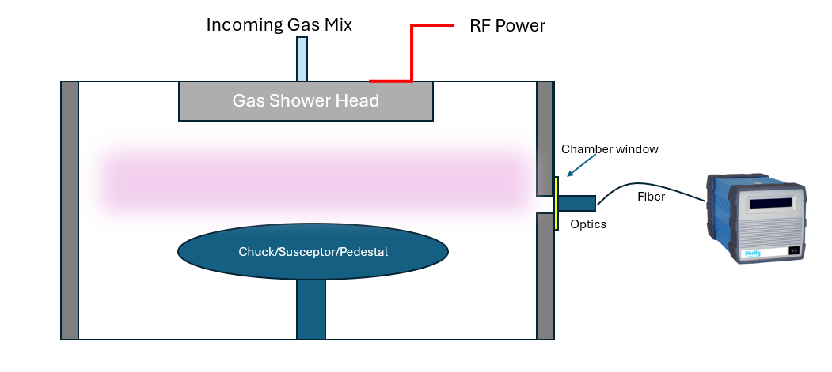

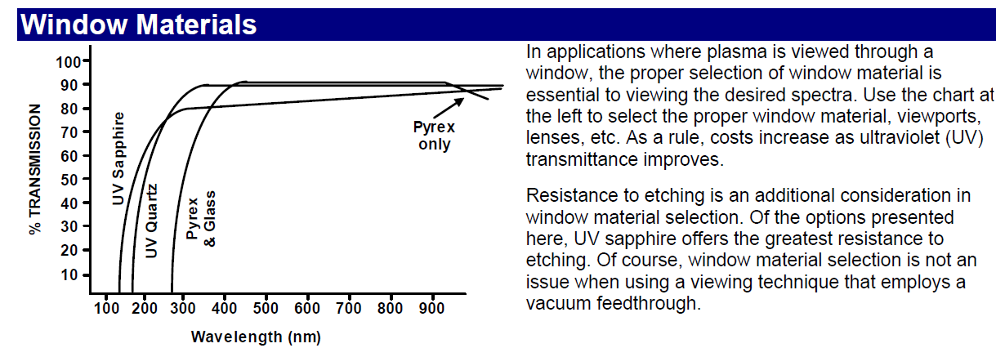

**Fiber Materials**

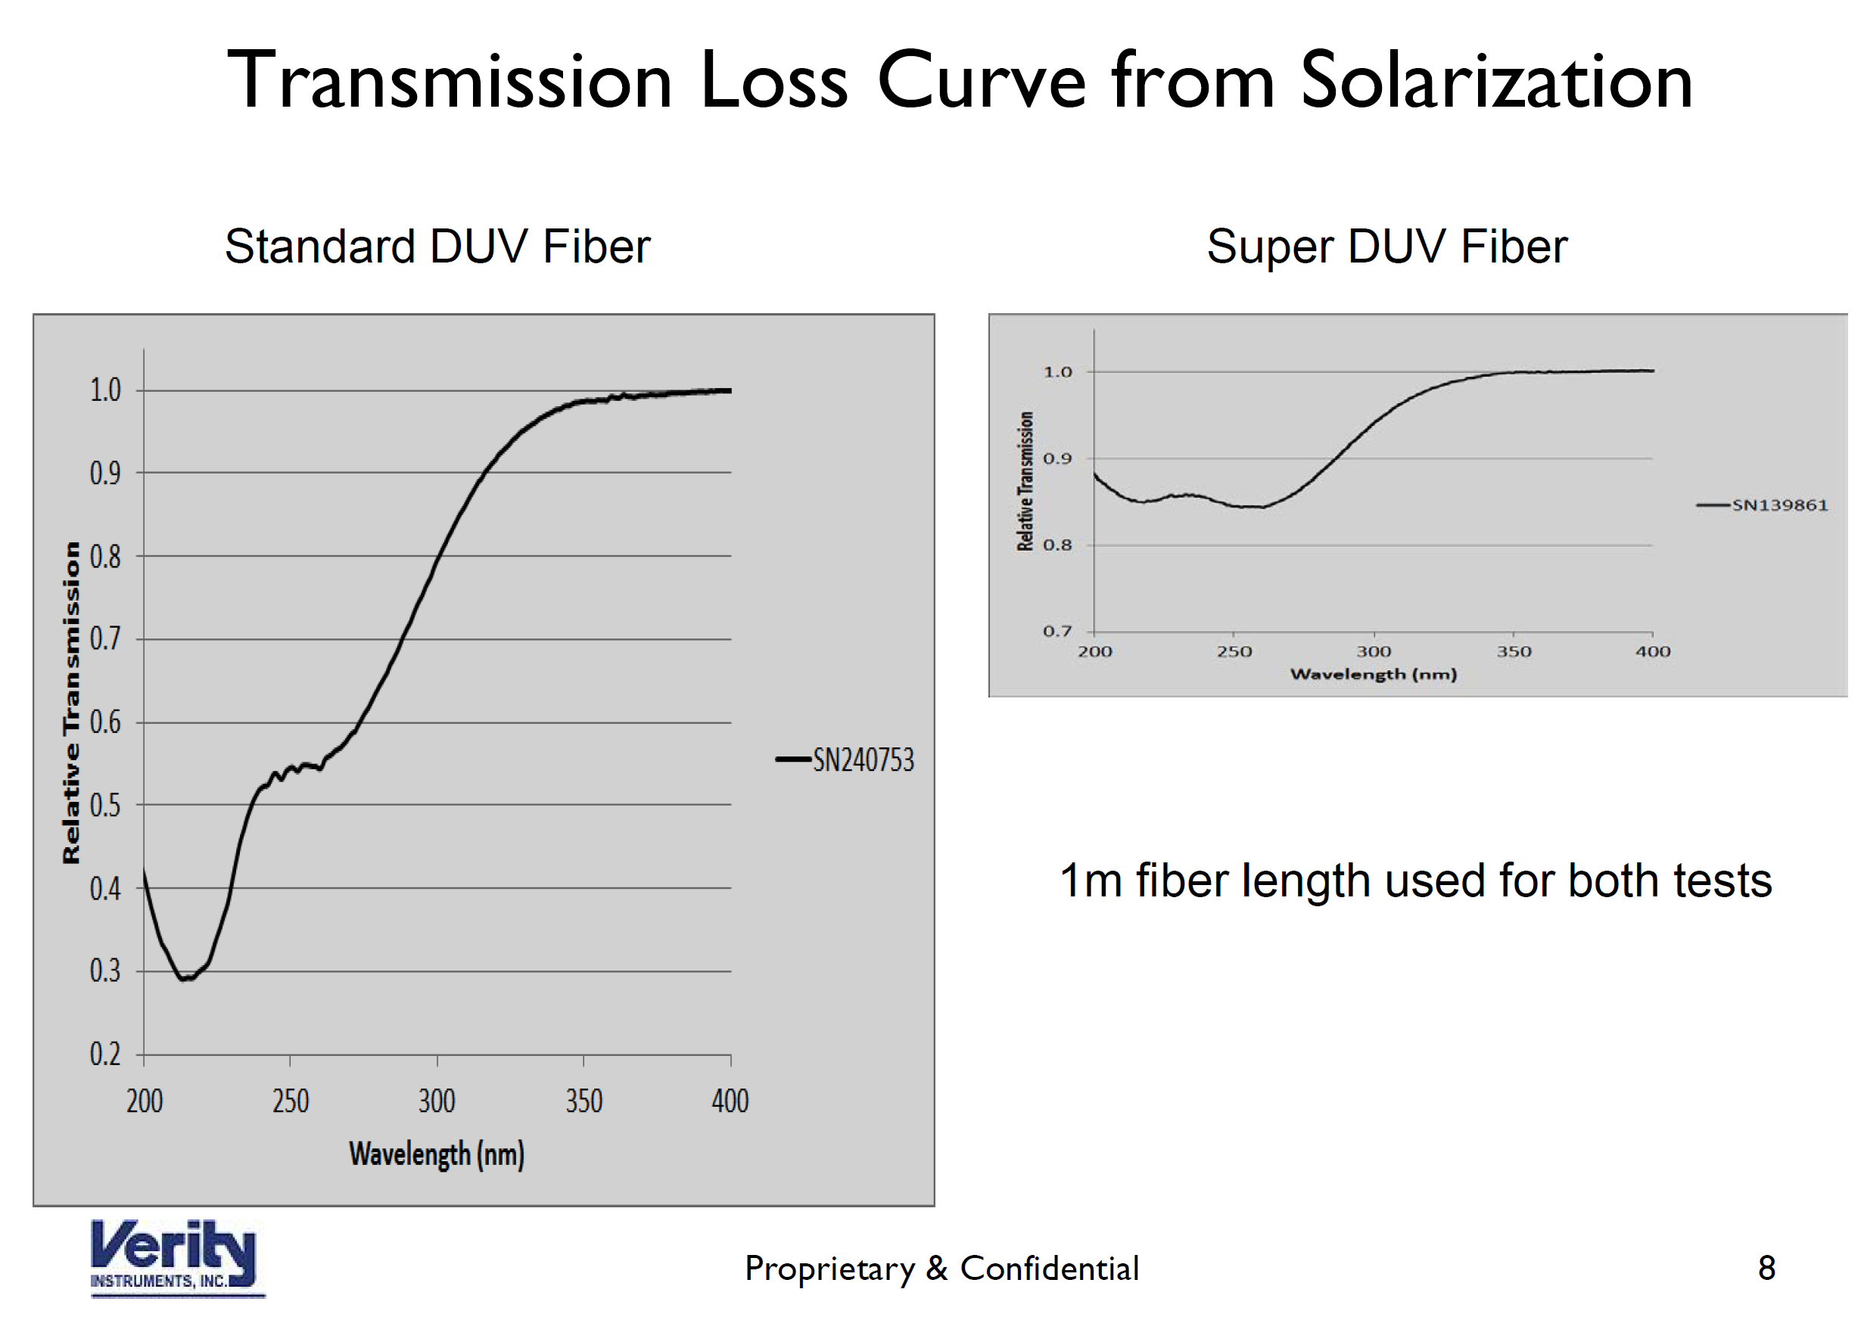

**Emission Table**

